Object Specifications

Controller: MCQBL

Class mcq_exam_master (Logical View::Design Model::Design Objects::Exam::mcq_exam_master )
Documentation: This is mcq_exam_master datatable to store exam details.
Cardinality [1 ]
Associated class mcq_exam_master documentation:
This is an entity for exam (datatable).

Class mcq_section_master (Logical View::Design Model::Design Objects::Section::mcq_section_master )
Documentation: This is mcq_section_master datatable to store exam section details.
Cardinality [1 ]
Associated class mcq_section_master documentation:
This is the datatable for section details.

Class mcq_question_master (Logical View::Design Model::Design Objects::Questions::mcq_question_master )
Documentation: This is mcq_question_master datatable to store exam question details.
Cardinality [1 ]
Associated class mcq_question_master documentation:
This is the main datatable for question pool module.

Class mcq_question_option (Logical View::Design Model::Design Objects::Questions::mcq_question_option )
Documentation: This is mcq_question_option datatable to store exam question option details.
Cardinality [ Undefined ]
Associated class mcq_question_option documentation:
This is the answer datatable for question pool datatable.

checkEmptyInteger(string sString) () : Boolean
Documentation:

GetAllExams () : DataTable
Documentation:

getAllExams(int ModId) () : DataTable
Documentation:

GetAllExamSections(int ExamId) () : DataTable
Documentation:

getAllExamsOnModule(int ModuleId) () : DataTable
Documentation:

GetExam(int examId) () : DataTable
Documentation:

GetQuestion(int question_id) () : DataTable
Documentation:

GetQuestionOptions(int question_id) () : DataTable
Documentation:

GetSection(int section_id) () : DataTable
Documentation:

GetSectionQuestions(int SectionId) () : DataTable
Documentation:

Page_Load(object sender, EventArgs e) () : void
Documentation:

Exam Maintenance

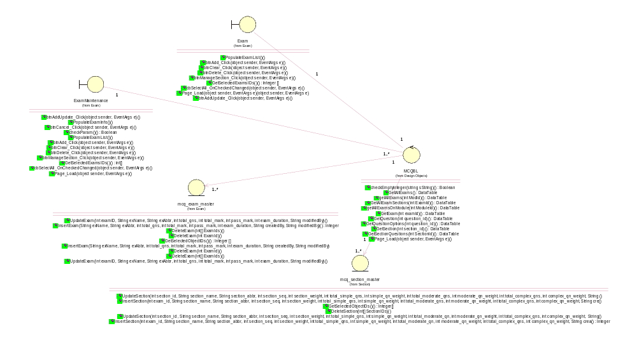

btnAdd_Click(object sender, EventArgs e) () : void
Documentation: This method allow portal admin to click on Add button on the interface.

btnAddUpdate_Click(object sender, EventArgs e) () : void
Documentation: This method is to allow portal admin to click on a button to update the exam data.

btnClear_Click(object sender, EventArgs e) () : void
Documentation: This method is to allow portal admin to clear/cancel the existing data entry.

btnDelete_Click(object sender, EventArgs e) () : void
Documentation: This method is to delete an exam from mcq_exam_master datatabe.

btnManageSection_Click(object sender, EventArgs e) () : void
Documentation: This method allows portal admin to create sections of an exam.

cbSelectAll_OnCheckedChanged(object sender, EventArgs e) () : void
Documentation: This method is to allow portal admin to select all the has been ticked to be removed.

GetSelectedExamsIDs() () : Integer []
Documentation: This method is to allow portal admin to select an exam to be modified/removed or to create sections.

Page_Load(object sender, EventArgs e) (object sender, EventArgs e) : void
Documentation: This method is to load the first page of the respective module.

PopulateExamList() () : void
Documentation: This method will extract the exam list from mcq_exam_master datatable.

DeleteExam(int ExamId) () : void
Documentation: This method will remove an exam from mcq_exam_master datatable.

DeleteExam(int ExamId) () : void
Documentation:

DeleteExam(int[] ExamIds) () : void
Documentation: This method will remove exams from mcq_exam_datatable.

DeleteExam(int[] ExamIds) () : void
Documentation:

GetSelectedObjectIDs() () : Integer []
Documentation: This method will extract info based on criteria in this array.

InsertExam (String exName, String exAbbr, int total_qns, int total_mark, int pass_mark, int exam_duration, String createdBy, String modifiedBy) : void
Documentation:

InsertExam(String exName, String exAbbr, int total_qns, int total_mark, int pass_mark, int exam_duration, String createdBy, String modifiedBy) () : Integer
Documentation: This method will insert exam details into mcq_exam_master datatable.

UpdateExam(int examID, String exName, String exAbbr, int total_qns, int total_mark, int pass_mark, int exam_duration, String modifiedBy) () : void
Documentation: This method will update the exam details to mcq_exam_master datatable.

UpdateExam(int examID, String exName, String exAbbr, int total_qns, int total_mark, int pass_mark, int exam_duration, String modifiedBy) () : void
Documentation:

btnAdd_Click(object sender, EventArgs e) () : void
Documentation: This method is to allow portal admin to click on button to add or update exam properties.

btnAddUpdate_Click(object sender, EventArgs e) () : void
Documentation: This method is to allow portal admin to click on button to add or update exam properties.

btnCancel_Click(object sender, EventArgs e) () : void
Documentation: This method allows portal admin to click on a button to cancel the exam maintenance operation.

btnClear_Click(object sender, EventArgs e) () : void
Documentation: This method will clear the data input on the interface to allow portal admin to key in new exam details.

btnDelete_Click(object sender, EventArgs e) () : void
Documentation: This method will allow portal admin to delete an exam or list of exams.

btnManageSection_Click(object sender, EventArgs e) () : void
Documentation: This method will allow portal admin to select the section maintenance module and transfer to section maintenance interface.

cbSelectAll_OnCheckedChanged(object sender, EventArgs e) () : void
Documentation: This method allows other method to extract/remove exam list based on the selection.

checkParam() () : Boolean
Documentation: This method is to check whether portal admin inputed the exam name / exam abbreviation.

GetSelectedExamsIDs() () : int[]
Documentation: This method is the buffer that stores the selection of exams from exam interface.

Page_Load(object sender, EventArgs e) () : void
Documentation: This method will display the exam / exam maintenance interface to portal admin.

PopulateExamInfo() () : void
Documentation: This method will extract the exam info from mcq_exam_master datatable.

PopulateExamList() () : void
Documentation: This method will extract exam list from mcq_exam_master datatable.

Question Maintenance

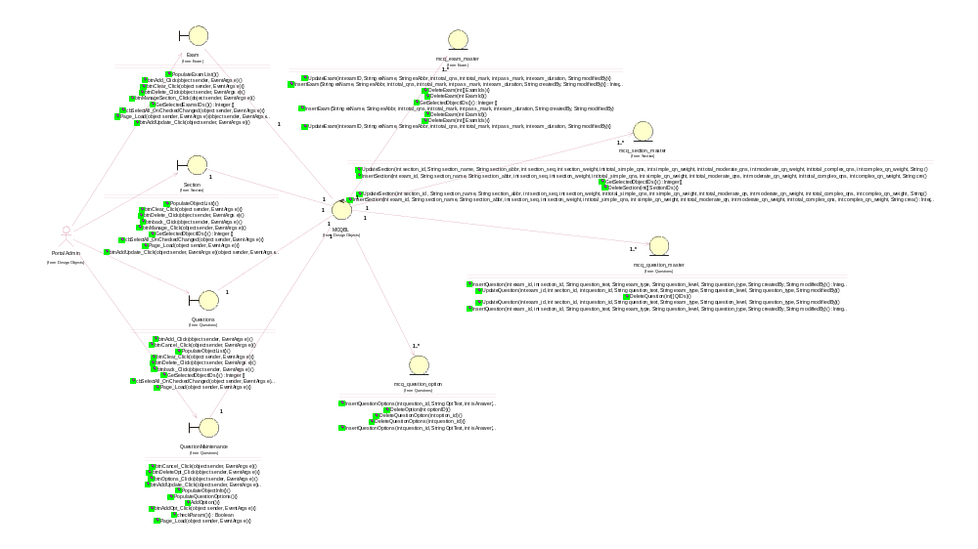

DeleteQuestion(int[] QIDs) () : void
Documentation:

InsertQuestion(int exam_id, int section_id, String question_text, String exam_type, String question_level, String question_type, String createdBy, String modifiedBy) () : Integer
Documentation: This method will insert the question details into mcq_question_master datatable.

InsertQuestion(int exam_id, int section_id, String question_text, String exam_type, String question_level, String question_type, String createdBy, String modifiedBy) () : Integer
Documentation:

UpdateQuestion(int exam_id, int section_id, int question_id, String question_text, String exam_type, String question_level, String question_type, String modifiedBy) () : void
Documentation: This method will update the question details into mcq_question_master datatable.

UpdateQuestion(int exam_id, int section_id, int question_id, String question_text, String exam_type, String question_level, String question_type, String modifiedBy) () : void
Documentation:

DeleteOption(int optionID) () : void
Documentation: This method will delete an option from a question.

DeleteQuestionOption(int option_id) () : void
Documentation:

DeleteQuestionOptions(int question_id) () : void
Documentation:

InsertQuestionOptions(int question_id, String OptText, int isAnswer) () : void
Documentation: This method will insert the question options details into mcq_question_option datatable.

InsertQuestionOptions(int question_id, String OptText, int isAnswer) () : void
Documentation:

btnAdd_Click(object sender, EventArgs e) () : void
Documentation: This method will allow portal admin to click a button to activate add question operation.

btnback_Click(object sender, EventArgs e) () : void
Documentation: This method will allow portal admin to click a button to go back question operation.

btnCancel_Click(object sender, EventArgs e) () : void
Documentation: This method will allow portal admin to click a button to cancel add/remove question operation.

btnClear_Click(object sender, EventArgs e) () : void
Documentation: This method will allow portal admin to click a button to clear question details.

btnDelete_Click(object sender, EventArgs e) () : void
Documentation: This method will allow portal admin to click a button to delete a question.

cbSelectAll_OnCheckedChanged(object sender, EventArgs e) () : void
Documentation: This method will buffer all the selections of portal admin on quetions.

GetSelectedObjectIDs() () : Integer []
Documentation: This method will buffer the portal admin's selections.

Page_Load(object sender, EventArgs e) () : void
Documentation: This method will load the interface on question.

PopulateObjectList() () : void
Documentation:

AddOption() () : void
Documentation: This method will add additional options into a question.

btnAddOpt_Click(object sender, EventArgs e) () : void
Documentation: This method allows portal admin to click on a button to add an option.

btnAddUpdate_Click(object sender, EventArgs e) () : void
Documentation: This method will update a question details into mcq_question_master.

btnCancel_Click(object sender, EventArgs e) () : void
Documentation: This method will allow portal admin to click the cancel button to cancel the maintenance operation.

btnDeleteOpt_Click(object sender, EventArgs e) () : void
Documentation: This method will allow portal admin to click the delete button to delete a question from datatable mcq_question_master.

btnOptions_Click(object sender, EventArgs e) () : void
Documentation: This method will allow portal admin to click the button to add additional options for a question.

checkParam() () : Boolean
Documentation: This method will validate a question parameters.

Page_Load(object sender, EventArgs e) () : void
Documentation: This method will load the interface for question maintenance.

PopulateObjectInfo() () : void
Documentation: This method will extract the question list and its options from datatable mcq_question_master and mcq_question_option.

PopulateQuestionOptions() () : void
Documentation: This method will extract the question option from mcq_question_option datatable.

Section Maintenance

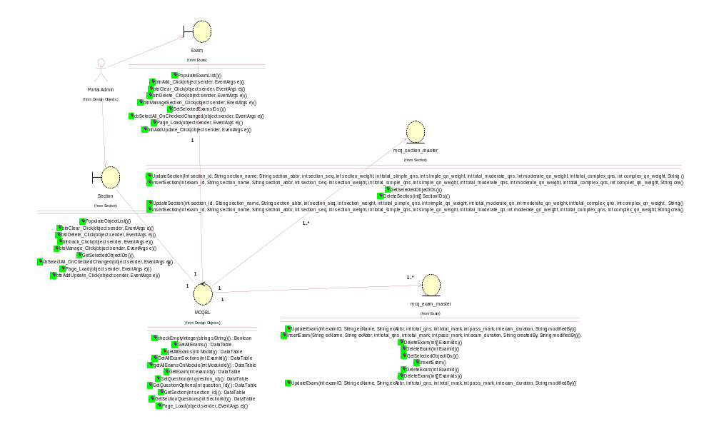

DeleteSection(int[] SectionIDs) () : void
Documentation:

GetSelectedObjectIDs() () : Integer[]
Documentation: This method will extract the section details based on portal admin's selection.

InsertSection(int exam_id, String section_name, String section_abbr, int section_seq, int section_weight, int total_simple_qns, int simple_qn_weight, int total_moderate_qn, int moderate_qn_weight, int total_complex_qns, int complex_qn_weight, String crea () : Integer
Documentation:

InsertSection(int exam_id, String section_name, String section_abbr, int section_seq, int section_weight, int total_simple_qns, int simple_qn_weight, int total_moderate_qns, int moderate_qn_weight, int total_complex_qns, int complex_qn_weight, String cre () : void
Documentation: This method will insert the section details of an exam.

UpdateSection(int section_id , String section_name, String section_abbr, int section_seq, int section_weight, int total_simple_qns, int simple_qn_weight, int total_moderate_qn, int moderate_qn_weight, int total_complex_qns, int complex_qn_weight, String () : void
Documentation:

UpdateSection(int section_id, String section_name, String section_abbr, int section_seq, int section_weight, int total_simple_qns, int simple_qn_weight, int total_moderate_qns, int moderate_qn_weight, int total_complex_qns, int complex_qn_weight, String () : void
Documentation: This method will update the section details of an exam.

btnAddUpdate_Click(object sender, EventArgs e) (object sender, EventArgs e) : void
Documentation: This method will add new section into exam.

btnback_Click(object sender, EventArgs e) () : void
Documentation: This method will go back to previous screen.

btnClear_Click(object sender, EventArgs e) () : void
Documentation: This method will allow portal admin to click on clear button to renew the interface for further operation.

btnDelete_Click(object sender, EventArgs e) () : void
Documentation: This method will allow portal admin to click on delete button to delete a section of an exam.

btnManage_Click(object sender, EventArgs e) () : void
Documentation: This method will allow portal admin to click on button to manage section interface.

cbSelectAll_OnCheckedChanged(object sender, EventArgs e) () : void
Documentation: This method select all items on records.

GetSelectedObjectIDs() () : Integer []
Documentation: This method will buffer the selection from portal admin and extract details from the mcq_section_master datatable.

Page_Load(object sender, EventArgs e) () : void
Documentation: This method will load the section interface.

PopulateObjectList() () : void
Documentation: This method will extract a list of section.

btnAddUpdate_Click(object sender, EventArgs e) () : void
Documentation: This method will add new section or update section details into mcq_section_master datatable.

btnCancel_Click(object sender, EventArgs e) () : void
Documentation: This method will allow portal admin to cancel an entry operation.

btnClear_Click(object sender, EventArgs e) () : void
Documentation: This method will allow portal admin to clear the entry page for further data entry.

checkParam() () : Boolean
Documentation: This method will check for validation of parameters on section interface.

Page_Load(object sender, EventArgs e) () : void
Documentation: This method will load the section interface.

PopulateObjectInfo() () : void
Documentation: This method will extract section details from mcq_section_master.
Survey Maintenance

SurveyBL Controller:

checkEmptyInteger(string sString) () : Boolean
Documentation: This method will do validation check.

GetAllSurveys() () : DataTable
Documentation: This method will get all surveys.

getAllSurveys() () : DataTable
Documentation: This method will get all surveys.

GetQuestion(int question_id) () : DataTable
Documentation: This method will get survey question.

GetQuestionOptions(int question_id) () : DataTable
Documentation: This method will get survey question options.

GetSurvey(int SurveyId) () : DataTable
Documentation: This method will get a survey.

GetSurvey(int SurveyId) () : void
Documentation: This method will get survey details.

GetSurveyQuestions(int SurveyId) () : DataTable
Documentation: This method will get survey question.

Page_Load(object sender, EventArgs e) () : void
Documentation: This method will load the interface.

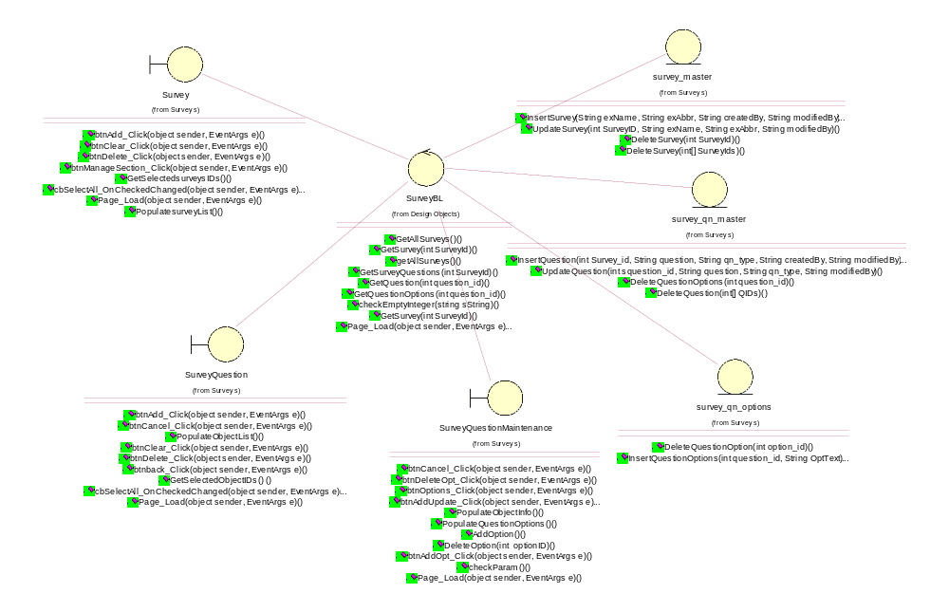

btnAdd_Click(object sender, EventArgs e) () : void
Documentation: This method allows portal admin to click on Add button.

btnClear_Click(object sender, EventArgs e) () : void
Documentation: This method allows portal admin to click on Clear button.

btnDelete_Click(object sender, EventArgs e) () : void
Documentation: This method allows portal admin to click on Delete button.

btnManageSection_Click(object sender, EventArgs e) () : void
Documentation: This method allows portal admin to click on manage question button.

cbSelectAll_OnCheckedChanged(object sender, EventArgs e) () : void
Documentation: This method allows portal admin to pick multiple selections.

GetSelectedsurveysIDs() () : Integer []
Documentation: This method will extract selected surveys from datatable.

Page_Load(object sender, EventArgs e) () : void
Documentation: This method will load the interface.

PopulatesurveyList() () : void
Documentation: This method will extract survey list from datatable.
DeleteSurvey(int SurveyId) () : void
Documentation: This method will remove 1 survey.

DeleteSurvey(int[] SurveyIds) () : void
Documentation: This method will remove 1 or more surveys.

InsertSurvey(String exName, String exAbbr, String createdBy, String modifiedBy) (String exName, String exAbbr, String createdBy, String modifiedBy) : void
Documentation: This method allows portal admin to insert new survey into datatable.

UpdateSurvey(int SurveyID, String exName, String exAbbr, String modifiedBy) () : void
Documentation: This method allows portal admin to update survey details into datatable.
DeleteQuestion(int[] QIDs) () : void
Documentation: This method will delete survey question from datatable.

DeleteQuestionOptions(int question_id) () : void
Documentation: This method will delete survey question option from datatable.

InsertQuestion(int Survey_id, String question, String qn_type, String createdBy, String modifiedBy) () : void
Documentation: This method will insert new survey question into datatable.

UpdateQuestion(int squestion_id, String question, String qn_type, String modifiedBy) () : void
Documentation: This method will update survey question details into datatable.
DeleteQuestionOption(int option_id) () : void
Documentation: This method will delete survey question options.

InsertQuestionOptions(int question_id, String OptText) () : void
Documentation: This method will insert survey question options.
btnAdd_Click(object sender, EventArgs e) () : void
Documentation: This method allows portal admin to click on Add button.

btnClear_Click(object sender, EventArgs e) () : void
Documentation: This method allows portal admin to click on clear button.

btnDelete_Click(object sender, EventArgs e) () : void
Documentation: This method allows portal admin to click on delete button.

btnManageSection_Click(object sender, EventArgs e) () : void
Documentation: This method allows portal admin to click on manage question button.

cbSelectAll_OnCheckedChanged(object sender, EventArgs e) () : void
Documentation: This method will allow portal admin to select multiple surveys.

GetSelectedsurveysIDs() () : Integer[]
Documentation: This method will allow the controller to extract survey id list from datatable.

Page_Load(object sender, EventArgs e) () : void
Documentation: This method will load the interface.

PopulatesurveyList () : void
Documentation: This method will extract survey list from datatable.
btnAdd_Click(object sender, EventArgs e) () : void
Documentation: This method allows portal admin to click on Add button.

btnback_Click(object sender, EventArgs e) () : void
Documentation: This method allows portal admin to click on back button.

btnCancel_Click(object sender, EventArgs e) () : void
Documentation: This method allows portal admin to click on cancel button.

btnClear_Click(object sender, EventArgs e) () : void
Documentation: This method allows portal admin to click on clear button.

btnDelete_Click(object sender, EventArgs e) () : void
Documentation: This method allows portal admin to click on delete button.

cbSelectAll_OnCheckedChanged(object sender, EventArgs e) () : void
Documentation: This method will pick multiple selection.

GetSelectedObjectIDs() () : Integer []
Documentation: This method will extract list of survey question from datatable.

Page_Load(object sender, EventArgs e) () : void
Documentation: This method will load the interface.

PopulateObjectList() () : void
Documentation: This method will populate the extracted list on interface.

AddOption() () : void
Documentation: This method will add additional option.

btnAddOpt_Click(object sender, EventArgs e) () : Boolean
Documentation: This method allow portal admin to click on add option button.

btnAddUpdate_Click(object sender, EventArgs e) () : void
Documentation: This method allows portal admin to click on update button.

btnCancel_Click(object sender, EventArgs e) () : void
Documentation: This method allows portal admin to click on cancel button.

btnDeleteOpt_Click(object sender, EventArgs e) () : void
Documentation: This method allows portal admin to click on delete button.

btnOptions_Click(object sender, EventArgs e) () : void
Documentation: This method allows portal admin to click on manage survey question button.

checkParam() () : void
Documentation: This method will do validation check.

DeleteOption(int optionID) () : void
Documentation: This method will delete an option.

Page_Load(object sender, EventArgs e) () : void
Documentation: This method will load the interface.

PopulateObjectInfo() () : void
Documentation: This method will populate the extracted list into interface.

PopulateQuestionOptions() () : void
Documentation: This method will populate the question option on interface.

